13.2 Vector Calculus
Giving Away the Punchline…
Do calculus component-wise!
$$r'(t) = ⟨x'(t), y'(t), z'(t)⟩$$
$$r″(t) = ⟨x″(t), y″(t), z″(t)⟩$$

Entry task Like HW 13.2 / 2–5
$$r(t) = ⟨t, cos(2t), sin(2t)⟩$$
Find r′(t), r(π/4), and r′(π/4).
Interpreting the derivative vector HW 13.2 / 2–4
Let’s take a look at this definition bit-by-bit…
$$r'(t₀) =\lim_{h→0}{\frac{r\left(t_{0}+h\right)-r(t_{0})}{h}}$$
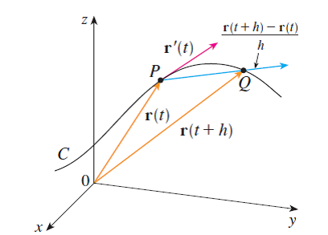

Unit tangent vectors HW 13.2 / 6–7
The unit tangent vector points in the direction of the tangent, but has length one..
$$T(t) =\frac{r^{'}\left(t\right)}{|r'(t)|}$$
Entry task continued
$$r(t) = ⟨t, cos(2t), sin(2t)⟩$$
Find T(t), then evaluate T(π/4).

Cool and Important Side Fact:
T(t) and T’(t) are always perpendicular
Tangent lines HW 13.2 / 8
Step 1: Find the point r(t₀).
Step 2: Find a direction r′(t₀).
$$<x,y,z> =r(t₀) + u r'(t₀)$$

continued (again)
$$r(t) = ⟨t, cos(2t), sin(2t)⟩$$
Find parametric equations for the tangent line at t = π/4.
Winter 2015 Exam 1 — Loveless
$$x = 2t, y = 5, z = t² - 10t$$
- There is one point on the curve at which the tangent line is parallel to the xy-plane.
Find the tangent line at this point.

Angles of intersection HW 13.2 / 9–10

- Find the angle of intersection of
$x=2t, y=5, z=t²-10t$
and
$x=7+u, y=2u+11,$ $z=u²+u-22.$
Integrate component-wise HW 13.2 / 11
$$\int{r^{'}\left(t\right)dt}=〈\int{x'(t)dt},\int{y'(t)dt}, \int{z'(t)dt}〉$$
Each component has its own constant. Use the initial position to find all three constants. We will discuss this more in 13.4.

Example
$$r'(t) = ⟨e³ᵗ, t⁴, t sin(t)⟩$$
$$r(0) = ⟨1, 3, -2⟩$$
Find r(t).

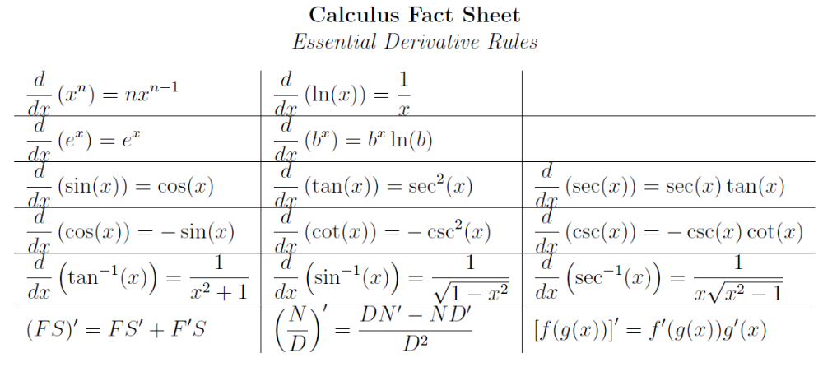
Derivatives Quick Review
A basic example: Write down
the derivative of
$$g\left(x\right)=x^{3}\cos\left(2x\right)+\sqrt{{1+e}^{3x}}$$

From my Calculus 1 Fact Sheet: math.washington.edu/~aloveles/Math126Materials/CalculusFactSheet2.pdf

Antiderivatives Quick Review
From my Calculus 1 Fact Sheet: math.washington.edu/~aloveles/Math126Materials/CalculusFactSheet2.pdf

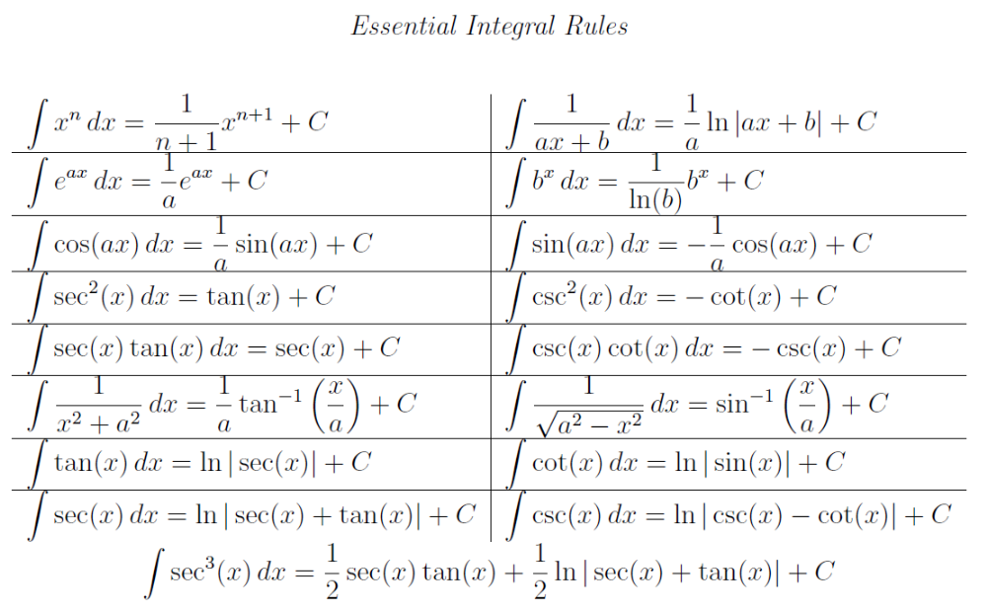
A basic example: Find $f(t)$, if
$$f’\left(t\right)=6\sqrt{t}+sin{(t)}+{9te}^{t^{2}}$$
with $f(0) = 7$.

For Ch. 13, you MUST remember:
- how to find +C.
- how to use u-substitution.
- How to use integration by parts.

